Bottom of Form

Top of Form

|  |
| --- |
|  |

Bottom of Form

**Azure vs. AWS: Key Differences**

**What is Azure?**

Azure is an open source and flexible cloud platform which helps in development, service hosting, service management, and data storage. The Azure cloud computing tool hosts web applications over the internet with the help of Microsoft data centers.

In this tutorial, you will learn

* [What is Azure?](https://www.guru99.com/azure-vs-aws.html#1)
* [What is Aws?](https://www.guru99.com/azure-vs-aws.html#2)
* [Comparison between Azure and AWS](https://www.guru99.com/azure-vs-aws.html#3)
* [Popularity Index with Market Share](https://www.guru99.com/azure-vs-aws.html#4)
* [Advantages of AWS](https://www.guru99.com/azure-vs-aws.html#5)
* [Advantages of Azure](https://www.guru99.com/azure-vs-aws.html#6)
* [Disadvantages of AWS](https://www.guru99.com/azure-vs-aws.html#7)
* [Disadvantages of Azure](https://www.guru99.com/azure-vs-aws.html#8)
* [Which one is better?](https://www.guru99.com/azure-vs-aws.html#9)

**What is Aws?**

Amazon Web Services is widely used secure cloud services platform, offering computing power, content delivery, database storage, and other functionality to help businesses scale and grow.

**Comparison between Azure and AWS**

[](https://www.guru99.com/images/1/031519_0732_AzurevsAWS1.png)

|  |  |  |
| --- | --- | --- |
| **Parameters** | **AWS** | **Azure** |
| Launched Date | Launched in 2006. | Launched In 2010. |
| Market Share | 31% Share of the global computing market | 11% Share from the worldwide market. |
| Availability Zone | 61 Availability Zone | 140 Availability Zones |
| Storage services | * S3 * Buckets * EBS * SDB * domains * Easy to use * SQS * CloudFront * AWS Import/Export | * Blob Storage * Containers * Azure Drive * Table Storage * Tables * Storage Stats |
| Databases Services | * MySQL * Oracle * DynamoDB | * MS SQL * SQL Sync |
| Deployment Services | * Amazon Web Services * Amazon Machine Instance (AMI) * Traditional Deployment Models * Fine-grained updates * Elastic Beanstalk * Cloud Formation | Cspkg (fancy zip file) Upload via portal or API via blob storage Course-grained updates "click to scale." More magic |
| Networking Services | * IP/Elastic IP/ELB * Virtual Private Cloud * Route 53 * ELB * Firewall heavily configurable | * Automatic IP assignment * Load-balancing * Azure Connect * Balancing * Endpoints defined in csdef/cscfg |
| Price | Per hour- rounded up | On-demand reserved spot. |
| Customers | Adobe, Airbnb, Expedia, Yelp, Nokia, Netflix, Novartis. | Pearson, 3M, Towers Watson, NBC, Essar, Serko, etc. |
| Type of Cloud | Virtual Private Cloud (VPC) | Virtual Network |
| Connection type | Direct Connect | ExpressRoute |
| Pricing models | * Free Tier * Per Hour * Free Trial Per Minute * No change for stopped * Pay for EBS volume | * Free Trial * Per Minute |
| Government Cloud | AWS has an edge as far as government cloud offerings. | Limited reach for government cloud offerings. |
| Support for Hybrid cloud | Does not offers the best of hybrid cloud support. | With Hybrid Cloud, organizations can integrate onsite servers with Cloud instances. |
| Ecosystem | AWS has a software marketplace with an extensive partner ecosystem. | With very few Linux options, Azure doesn't' have a big ecosystem. |
| Support for Big Data | EBS storage is ideal for handling big data. | Standard storage has many issues for big data, and therefore you need premium storage. |
| Maturity | More mature cloud environment for big data. | The less mature environment for big data. |
| Machine access | In AWS machine can be accessed separately. | Machines are grouped into cloud service and respond to the same domain name with various ports. |
| Salary | The average salary for "AWD engineer" is approximately $141,757 per year for Software Architect. | The average salary for "Microsoft Azure" ranges from approximately $113,582 per year. |
| Key features | Zero setups, Detail Monitoring, Auto-scaling groups. | Startup friendly, High performance, Low cost. |
| Long term data archiving | Allows long term data archiving and retrieval. | Does not offer any long term data archiving and retrieval option. |
| Security | Security is provided using defined roles with permission control feature. | Provides security by offering permissions on the whole account. |

**Popularity Index with Market Share**

[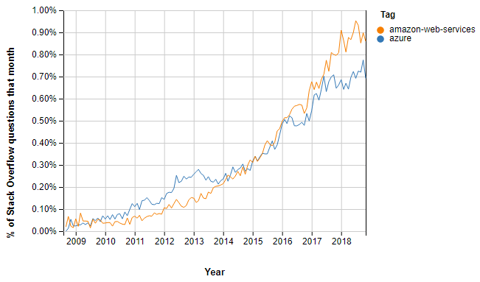](https://www.guru99.com/images/1/031519_0732_AzurevsAWS2.png)Stack Overflow Questions AWS vs. Azure

AWS continues to dominate a global cloud-infrastructure services industry which is likely to hit proximately $70 billion last year. Today, it enjoys market share which is better than some top public cloud providers.

[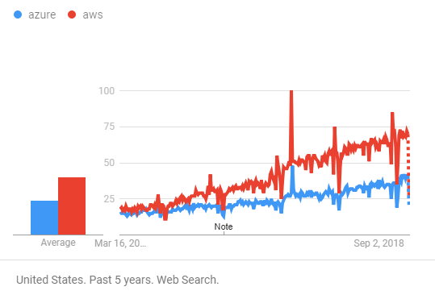](https://www.guru99.com/images/1/031519_0732_AzurevsAWS3.png)Google Trends Azure vs. AWS

In the past year, Azure's cloud adoption rate is almost 85 percent that of AWS', up from 70 percent last year.

[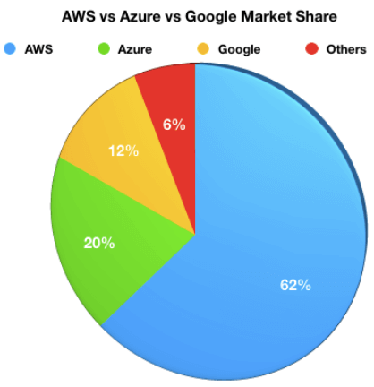](https://www.guru99.com/images/1/031519_0732_AzurevsAWS4.png)

**Advantages of AWS**

Here, are significant advantages of adopting AWS cloud services:

* Compute Cloud allows you to increase or decrease storage according to the need of your organization
* AWS enables you to select an operating system, programming language, database of your choice.
* Broad & deep service offerings
* Robust partner ecosystem
* Trusted by high-profile customers
* High Transfer Stability
* Minimal information is lost during server and storage transfer
* Offers more data centers for availability and low latency
* Better DevOps support
* Simpler licensing method
* Stronger support for Bl and analytics

**Advantages of Azure**

Here, are some major advantages of using Azure cloud services:

* Capability for developers and users to create, maintain and deploy applications
* Fully scalable cloud computing platform offers open access across multiple languages, frameworks, and tools
* Total support for Microsoft legacy apps
* Greater awareness of enterprise needs
* Easy one-click migrations in many cases
* Conversion of on-prem licenses to the cloud
* Support for mixed Linux/Windows environments
* Offers inbuilt tool like Azure stack to help the organization deliver Azure service from the own data center

**Disadvantages of AWS**

Here, are few drawbacks of Amazon Web Services:

* Less hybrid- cloud-friendly
* AWS elastic load balancer is not equipped to handle as many requests as it receives
* AWS lacks customer support, so it more suitable for a technically savvy group of consumers and those companies who have their inbuild tech support team
* The number of choices offered by AWS is confusing to those who may not speak the language of technology.
* Incompatible and Weak Hybrid Strategy
* AWS is a less open private cloud. This makes it an unpopular storage option for sensitive industries like banking
* AWS has too many products which makes the selection process much harder

**Disadvantages of Azure**

The major Drawbacks of Azure cloud services are:

* Customer service is not transparent, and data is hosted globally. So, if you have data restrictions where it must be stored in a specific country, at that time you need to verify/specify with Microsoft
* You will be charged extra for paying as you go
* Azure cloud-based services are full of glitches. To fix these bugs, you will need to spend additional money
* Less flexibility about non-Windows server platforms, when compared to AWS

**Which one is better?**

Microsoft Azure has increased its market share in the last couple of years, but not to an extent where there is a real contest between the two companies at least for the near future.

Moreover, both companies introduce new products, new integrations, and new pricing structures. Therefore, the final selection will be depend on the need of your organization.

**KEY DIFFERENCE**

* Both Azure and AWS supports hybrid cloud but Azure supports hybrid cloud better.
* Azure offers express routes while AWS offers direct connection.
* Azure provides security by offering permissions on the whole account whereas AWS security is provided using defined roles with permission control feature.
* Azure machines are grouped into cloud service and respond to the same domain name with various ports whereas the AWS machine can be accessed separately.
* Azure has a virtual network cloud whereas AWS has Virtual Private Cloud.
* Azure has 140 availability zone whereas AWS has 61 availability zone.